**50) Take the sample application node js and build it- > deploy to s3.**

* Sudo mkdir node-app
* Cd node-app
* Sudo npm init -y

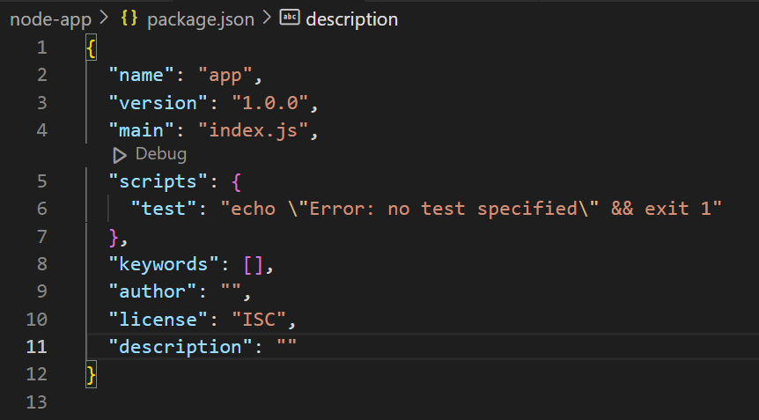

**Next, create a Node-app.js**

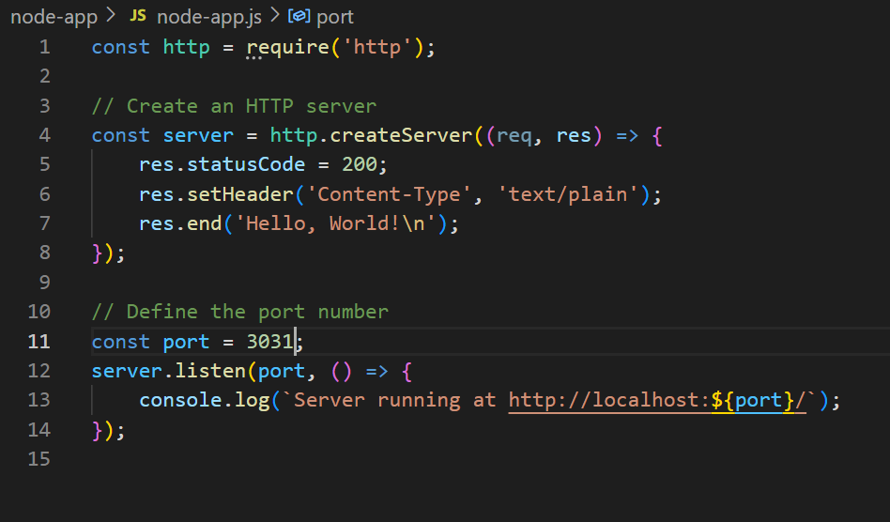

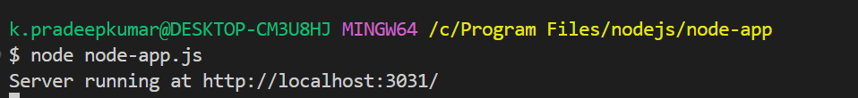

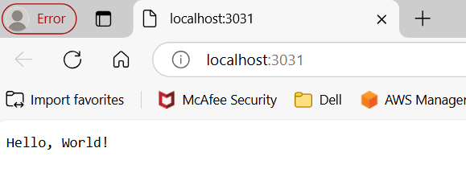

**Create the S3 bucket and upload the application(.ZIP file) into the s3 bucket**

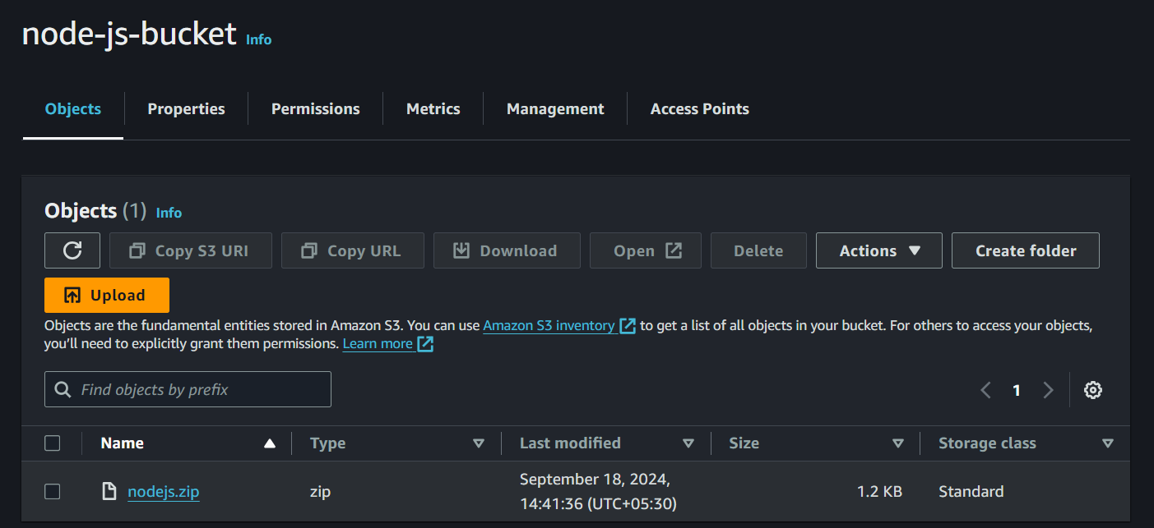

**Shell Script of the node js application**

Save the script file as nodejs.sh

Give execute permission to the script:

chmod +x nodejs.sh

Run the script:

./nodejs.sh

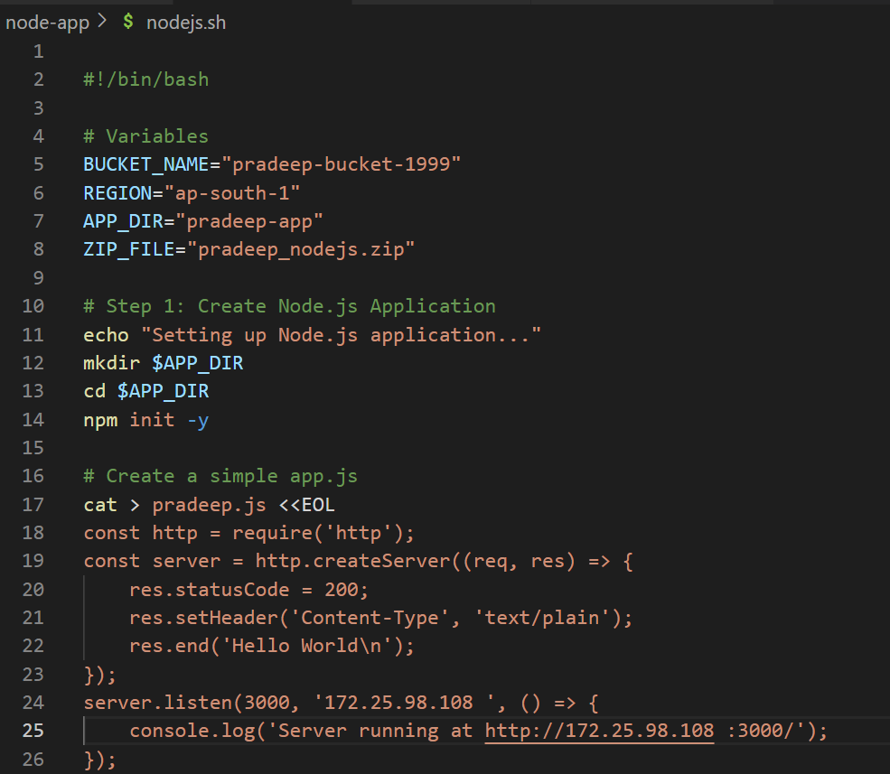

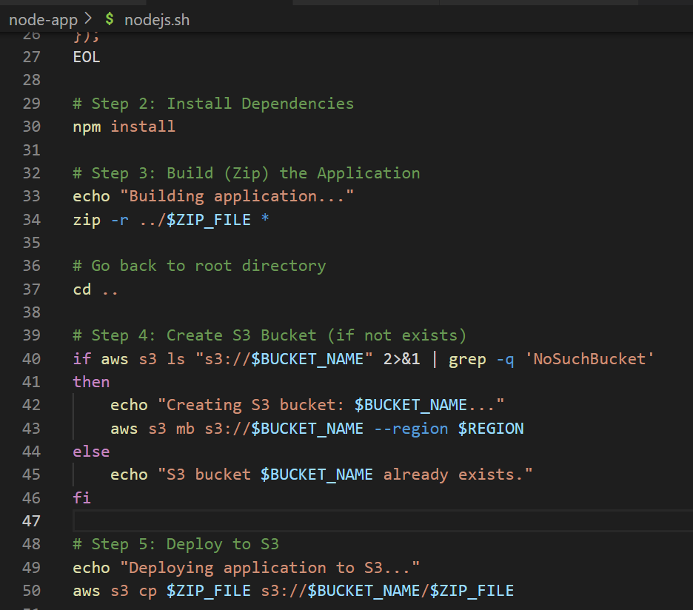

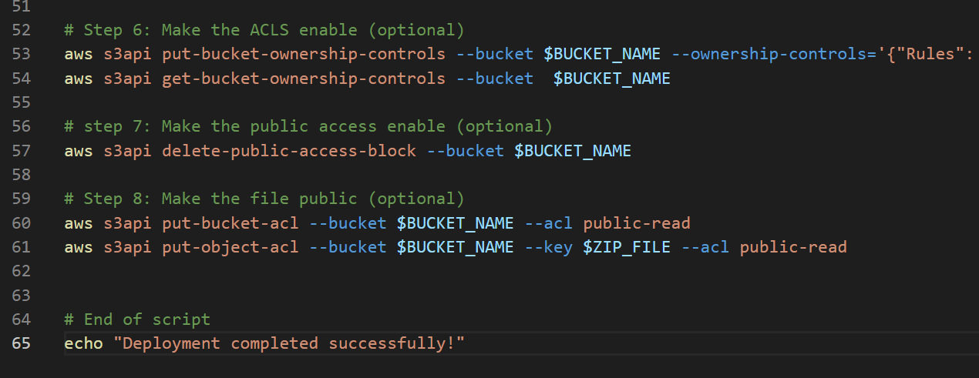

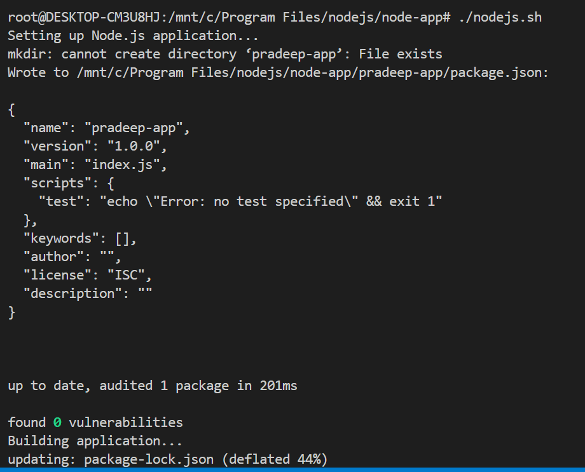

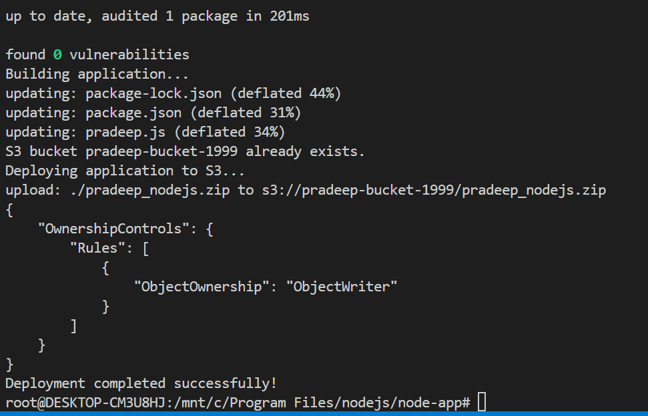

**51) Create an alarm for a specific instance (e.g., monitoring a network load graph) and add it to an SNS topic to send email alerts.**

First create the sns-topic and subscribe it using our email

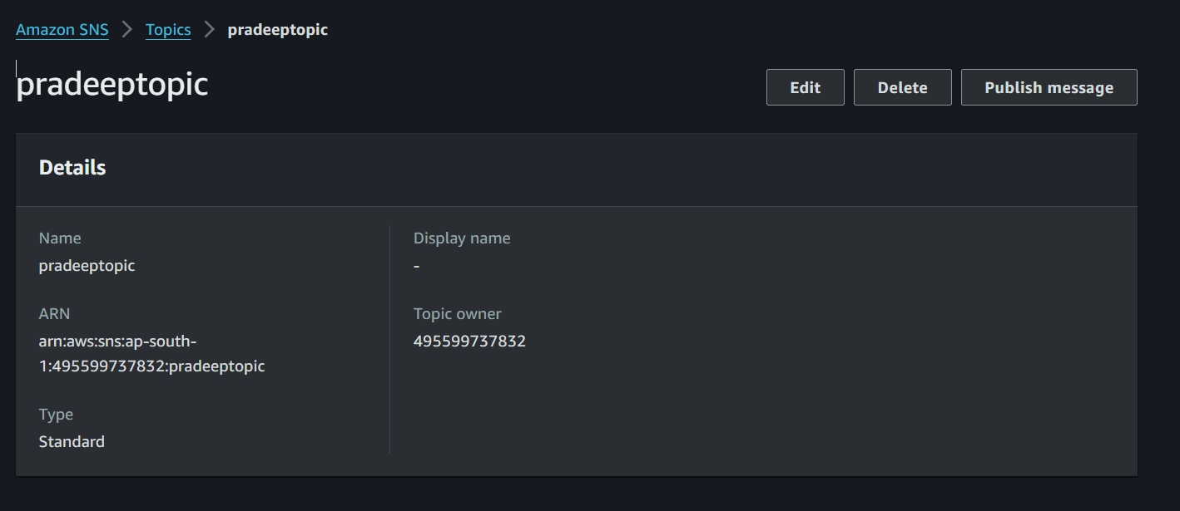



Next create an alarm

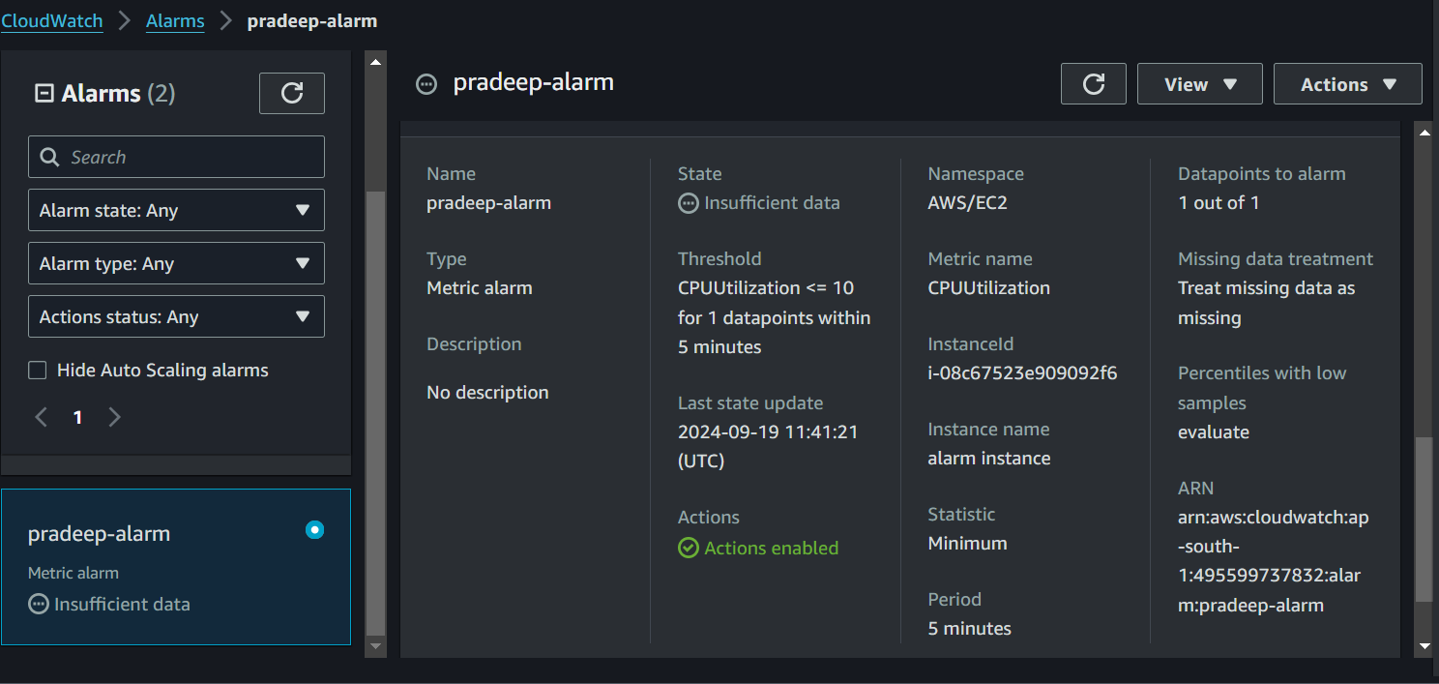

After created an alarm that alert sent to the mail

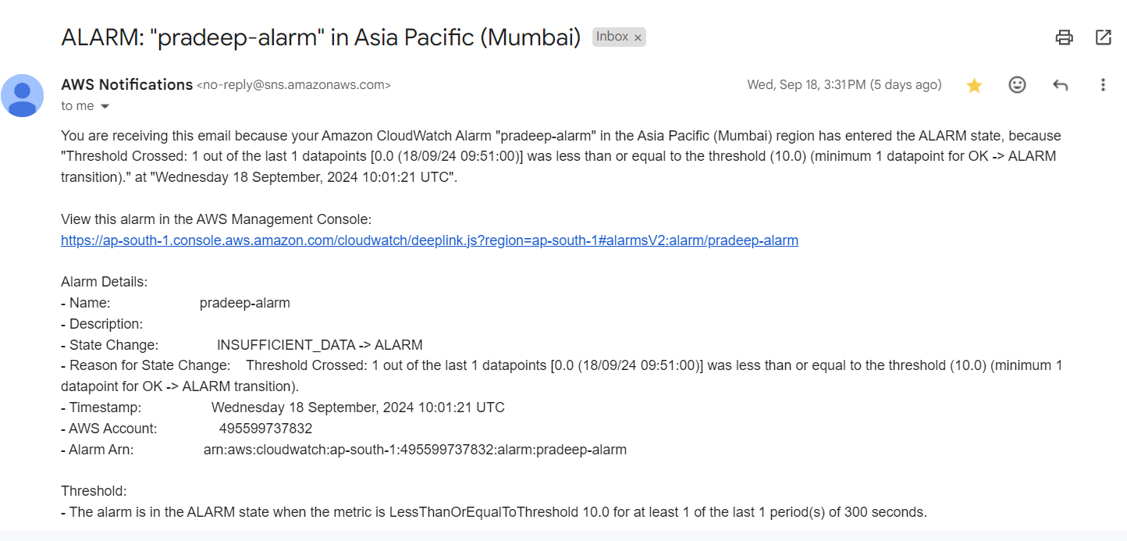

**USING CLI**

**Create an sns-topic with the name NetworkLoadAlerts**

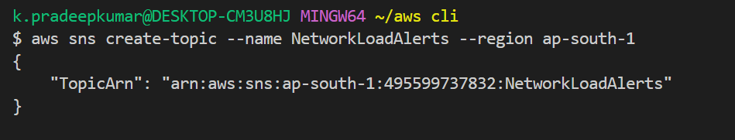

**Subscribe an Email to the SNS Topic**

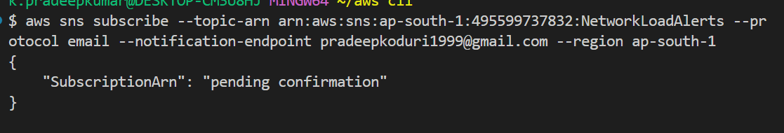

**Create cloudwatch alarm**

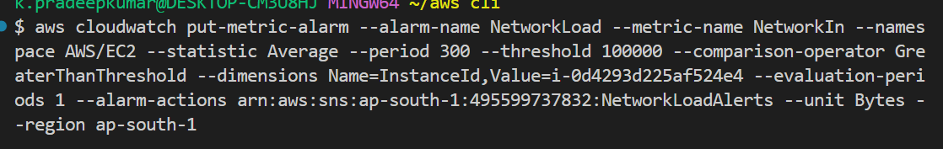

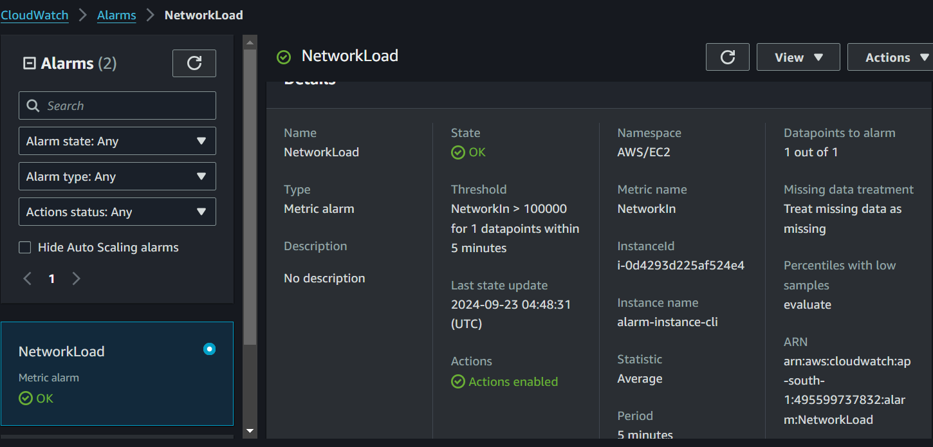

**52)Create an SNS topic and add an email address for notifications.**

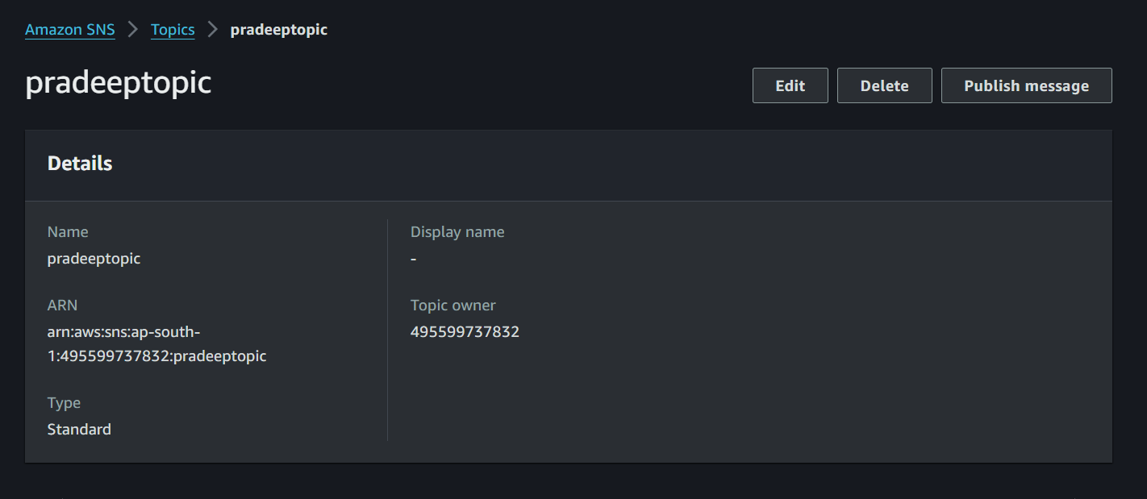

And subscribe the sns topic using email



When we subscribe using our mail an sns notification be received to our 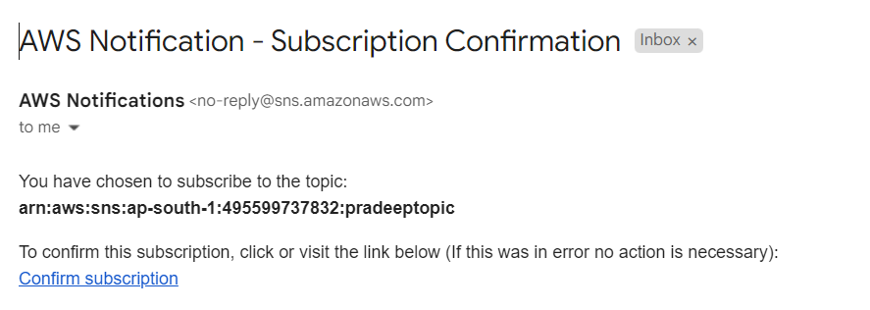

To test an sns topic i added an raw message to the sns topic weather it subscribed correctly or not

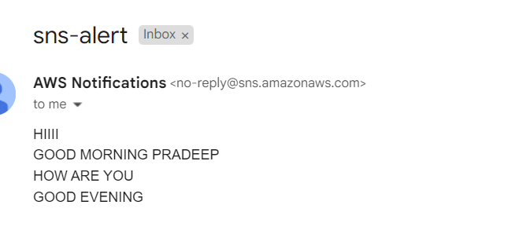

**USING CLI**

Create an sns-topic

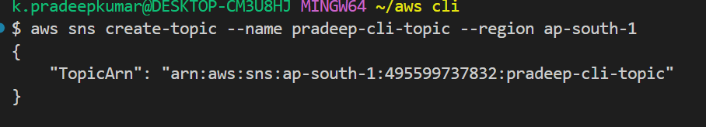

Subscribe it to an email

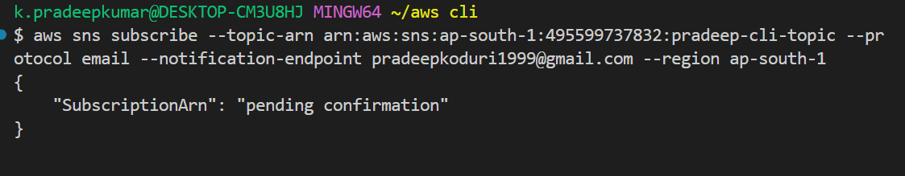

When we subscribe an alert be send to our email

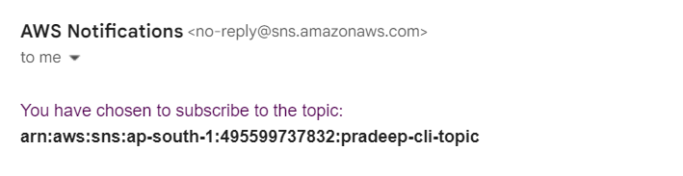

Send an message to the sns-topic weather the sns-topic is correctly subscribed or not

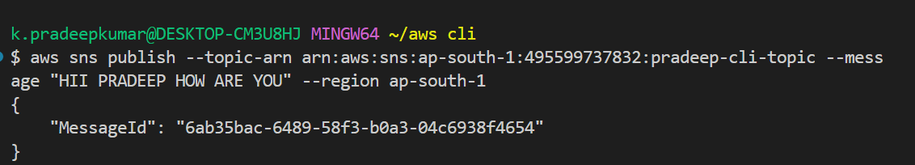

An message notification be send to our email

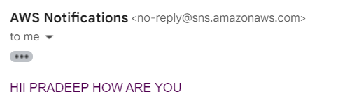

**53) Create an SQS queue and subscribe to the previously created SNS topic.**

Create a queue

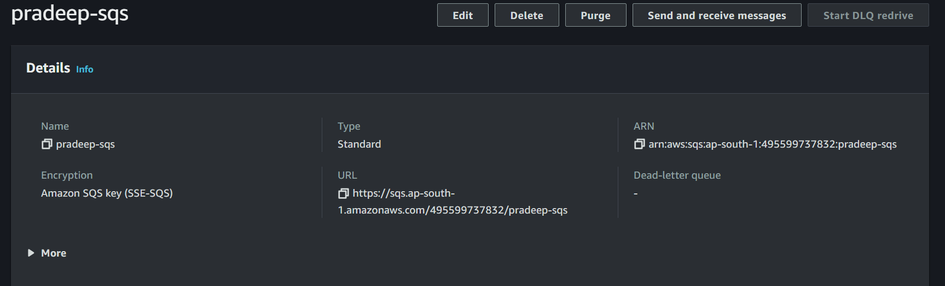

**Subscribe the SQS Queue to the SNS Topic**



**USING CLI**

Create a sqs

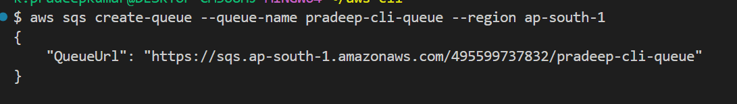

Subscribe the SQS Queue to the SNS Topic

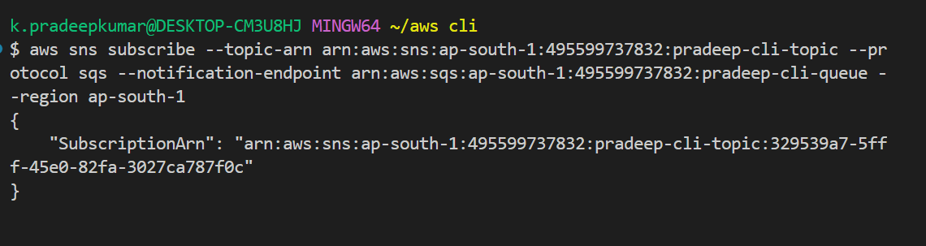

**54)Verify if the messages are being sent correctly from SQS.**

### **Select the Queue**

In the SQS dashboard, you will see a list of your queues.

Select the queue you subscribed to the SNS topic

**View Messages in the Queue**

Once inside the queue details page, you will see metrics like Number of messages available and Number of messages in flight.

To see the messages that have been sent to the queue:

Click on Send and receive messages (found on the top right).

On the next page, click Poll for messages.

SQS will retrieve the messages that are in the queue. You should see a list of messages that have been sent.

### **Inspect the Message Content**

If messages are found, click on the Message ID or Body to see the full message details.

The message body will contain the message that was published from the SNS topic, and you can verify if it matches what was sent.

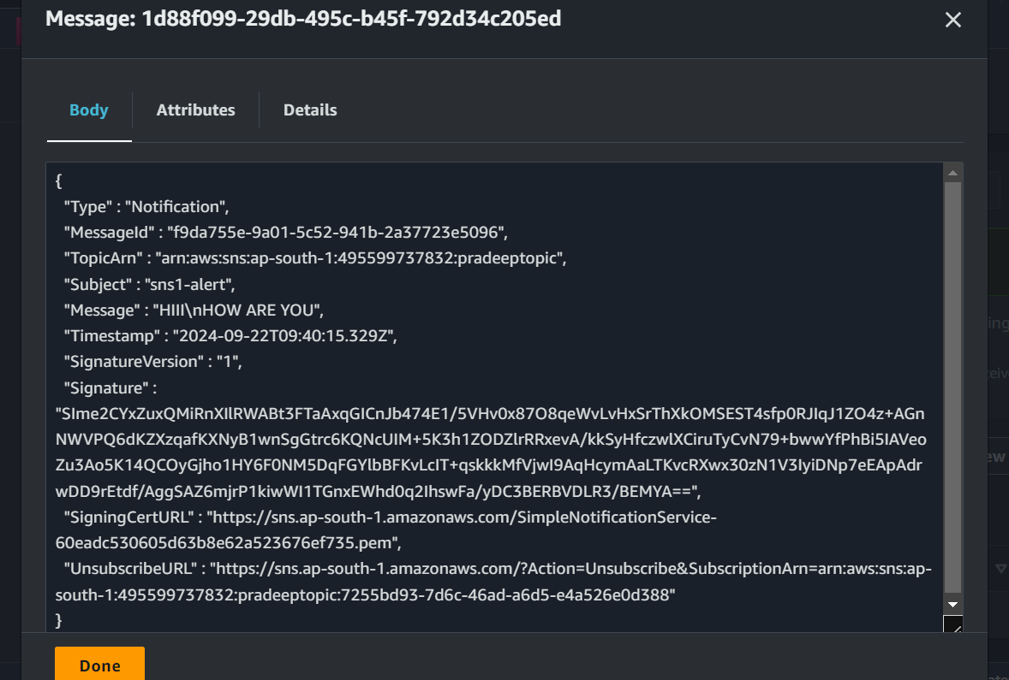

**USING CLI**

1. **Send a Test Message to SNS Topic**

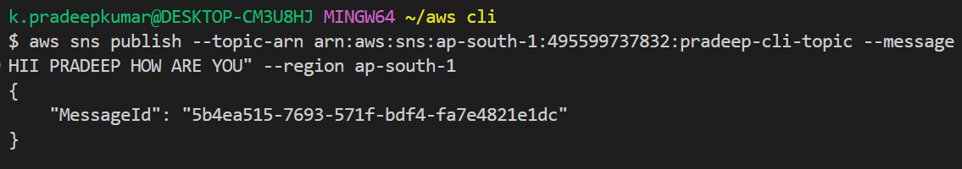

**Receive the Message from SQS**

